Daddy Dearest

Available on Digital HD September 15 and Blu-ray & DVD October 1

The relationship between a father and his daughter is a very precious thing. Some of the most touching scenes from movie history are the loving moments between dads and daughters. In The Croods, we watched as Eep and Grug slowly come to realize how much they truly love each other. Take a look at five of the most memorable dad and daughter moments in movie history.

Join the Croods on the journey of a lifetime in the epic comedy-adventure that "has the magical wonder of How To Train Your Dragon" - Jake Hamilton (Fox-TV). When their cave is destroyed, the Croods set out to explore a spectacular landscape filled with fantastic creatures, strange surprises…and a whole new world of adventure!

Eep and Grug - The Croods

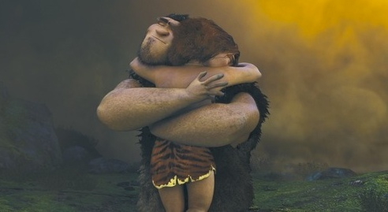

Teenagers always go through that phase of life where they feel that they are being smothered by their parents. Eep is definitely feeling these emotions when her over-protective dad keeps her under tight boundaries. But it turned out that Eep and Grug were more alike than they realized. Eep’s heart is broken when she thinks she lost her opportunity to tell her dad how much she loves him. In a very memorable moment, Eep and Grug are reunited and our hearts melt as we watch them embrace in a great big word that rhymes with Grug… a hug!

Charlie & Bella Swan - The Twilight Saga

Throughout the Twilight saga, there are multiple adorably awkward father-daughter moments shared between Charlie and Bella. Charlie may not always know exactly what he is doing, but there is no denying that he is an excellent father! Our favorite Charlie and Bella memory is the day of the wedding. Before heading off on her honeymoon, Charlie tells Bella how much she means to him and the two share a meaningful moment.

Bryan and Kim Mills - Taken

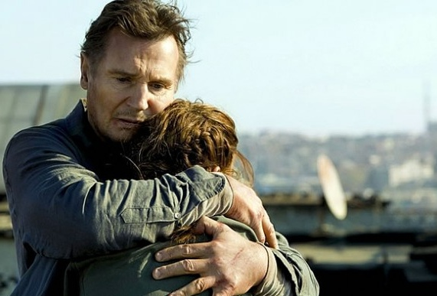

Every girl wants a father who makes them feel safe and is willing to protect them from any kind of harm that comes their way. Bryan Mills represents the ultimate dad in Taken and Taken 2 as he takes down anyone who comes between him and his daughter. Kim is lucky to have such a fierce father figure in her life and their relationship benefits from the difficult situation that she faces.

George & Annie Banks - Father of the Bride

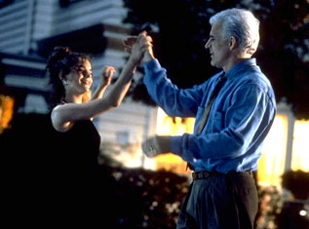

In Father of the Bride, George might be having a hard time giving up his little girl, but in the end he accepts the wedding as a reality and the two have a major bonding moment. On the night before her wedding, Annie and George play basketball in the driveway and hundreds of female viewers thought back to the times they played sports with their dad as a kid.

Graham, Sophie, and Olivia - The Holiday

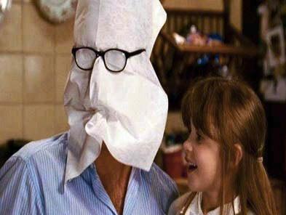

Being a single dad and raising two daughters is no easy task. In The Holiday, Graham seems to be one of the greatest single parents we’ve ever seen. From being Mr. Napkin Head with his two adorable daughters to building a dreamy tent with fluffy pillows and hand-cut stars, Graham goes the extra step to make sure Sophie and Olivia have a great childhood. We love the moment when we find out that the father and his daughters call themselves “the three musketeers.”

